Power BI Capstone Project – Dashboard Report

This document provides a comprehensive explanation of the Power BI dashboard developed as part of the capstone project.
Each section corresponds to a specific analytical question, detailing the visualization used and the key insights derived.
Actual dashboard visuals has been attached for the complete review and detailed explanation.

- Top 10 Product Categories by Total Sales:

Question Statement:
Identify and visually represent the top 10 product categories by total sales.

Visualization:
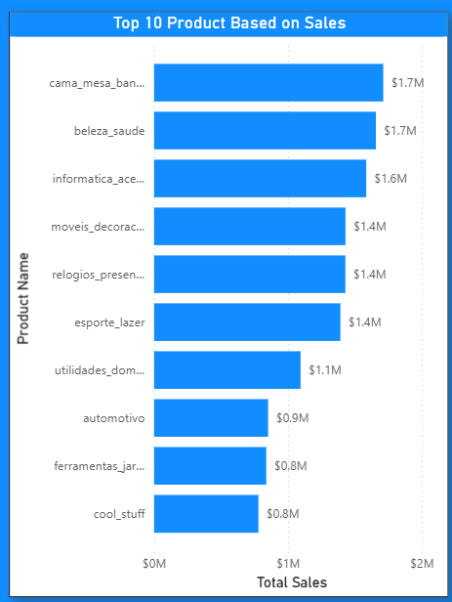

Explanation:
The chart ranks product categories based on total sales value.
This visualization helps identify high-performing categories that contribute most significantly to overall revenue, enabling focused inventory and marketing decisions.

- Delayed Orders Analysis:

Question Statement:
Determine the number and proportion of delayed orders.
Visualization:
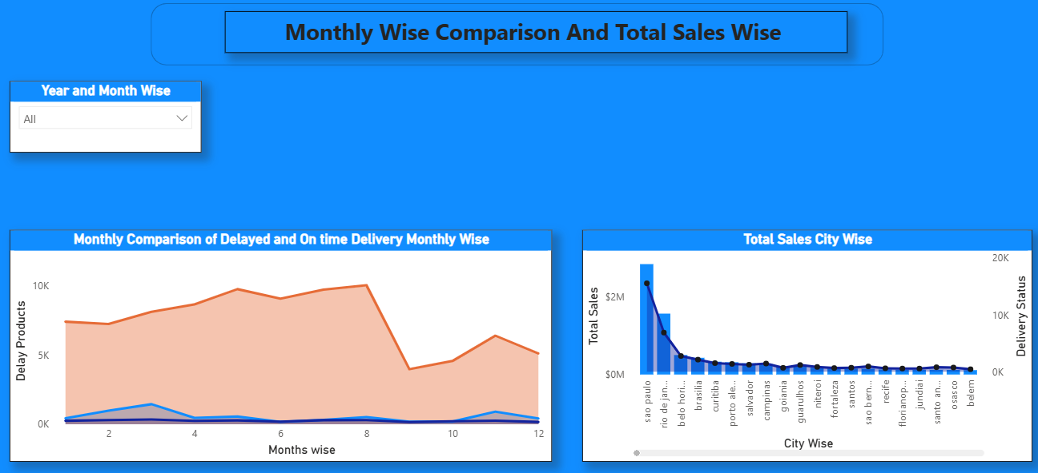

Explanation:
The above visual highlights delayed versus on-time orders, helping stakeholders understand operational inefficiencies and areas for logistics improvement.
Reason for delay is because delivery of the order has exceeded the actual delivery time has increased the delayed delivery of orders.
Red color is the on-time delivery of the product, and the blue line indicates Delay in the product and dark blue indicates there is no orders present.
As we increase the delivery employees delayed delivery can also be decreased and deliveries can also be on time.

- Sales Trend Over Time:
Question Statement:
Analyse sales trends over time to identify seasonality and growth patterns and quarterly distributed and yearly wise revenue generated increase and decrease.
Visualization:

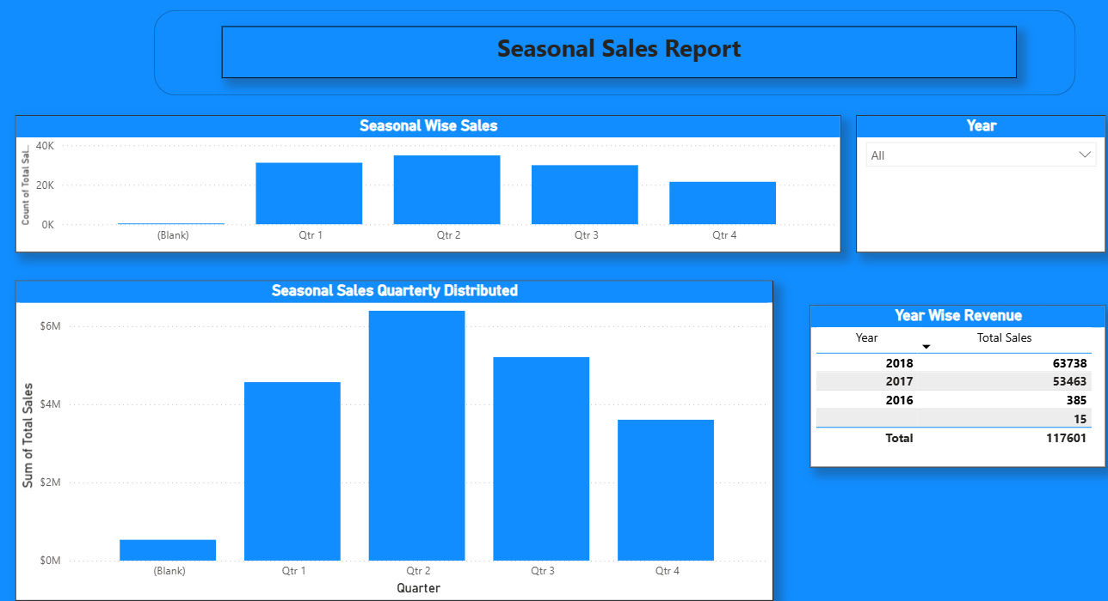

Explanation:
The above Column chart illustrates fluctuations in sales across different periods, revealing peak seasons and long-term performance trends as per sales.

- Payment Method Analysis:

Question Statement:
Related to the type of the payment customer has used for the product.
Visualization:

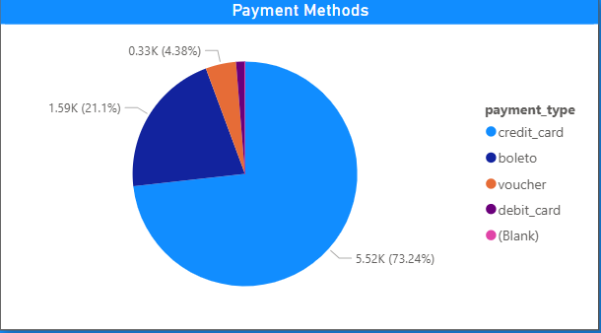

Explanation:
It describes about the type of payment used like credit card, boleto, voucher, debit card or cash payment.

- Product Rating Analysis:

Question Statement:
Determine top 10 high rated products and bottom 10 lowest rated products.
Visualization:

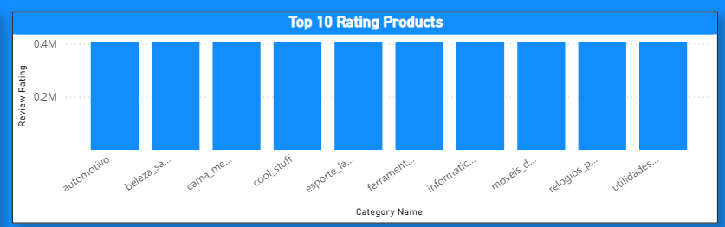
Above is the Top 10 rated products which is good product which has rated by customer as best review.

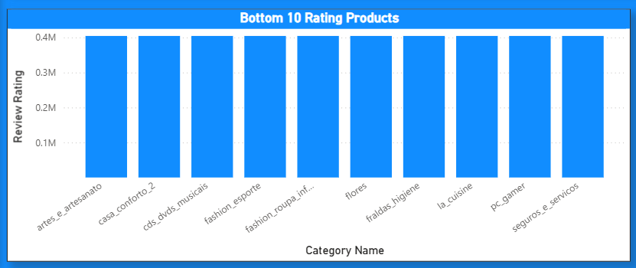

Above chart is the Bottom 10 rated products which is low product which is rated by customer as less review.

- State wise Sales Analysis:

Question Statement:
Identify and Visualize represent state wise high and low sales.

Visualization:
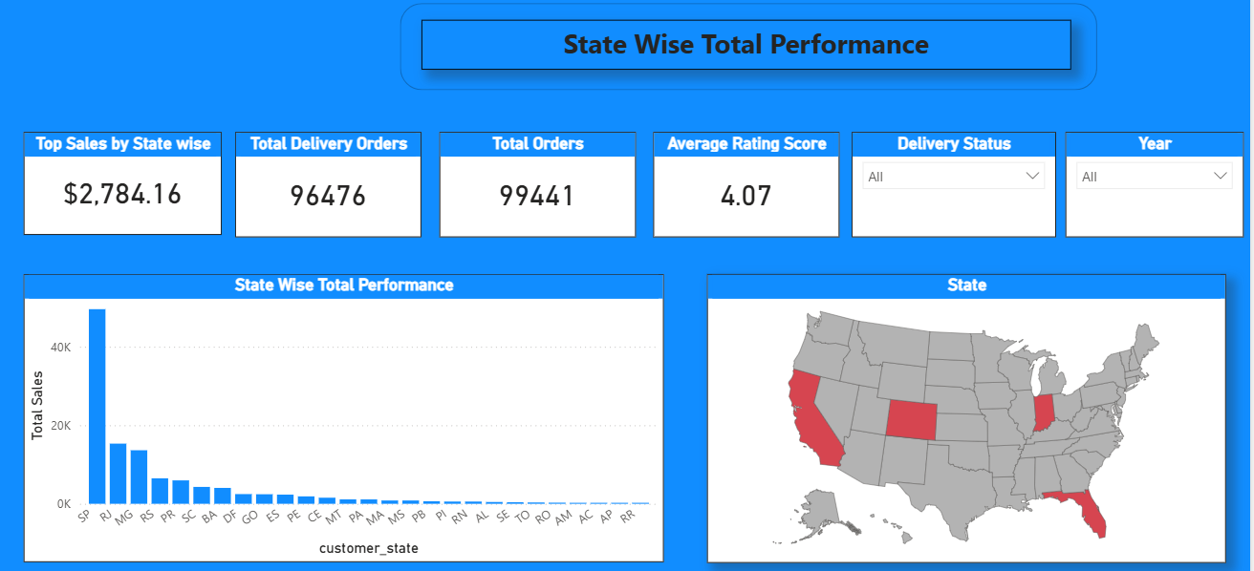

Explanation:

Above Analysis shows about the total sales state wise and total orders that has been delivered and average rating of the total ratings.
It shows which state has highest orders delivered as per year and check as per delivery status.

- Seasonal Sales Pattern:

Question Statement:
Investigate Quarterly seasonal sales over years.

Visualization:
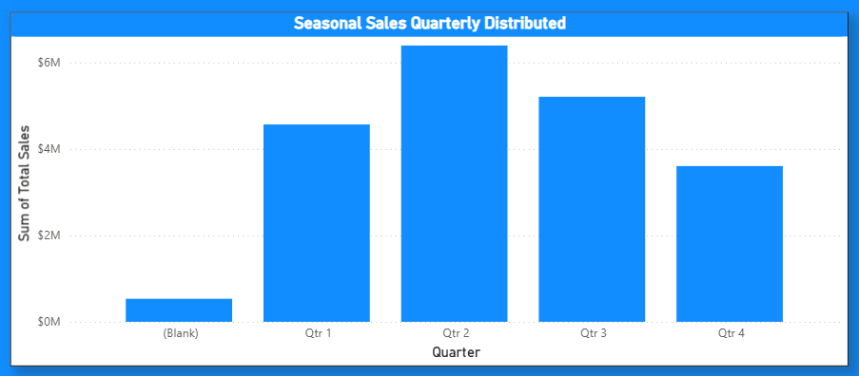

Explanation:
Above Analysis describes in which quarter maximum orders has met on yearly basis. It helps in avoiding delay delivery duration by placing more delivery person at that quarter to have good holding in the revenue and sales.

- Revenue Analysis:

Question Statement:
Determine total revenue generated by Shop Nest Store and analyse how it changes over time.

Visualization:

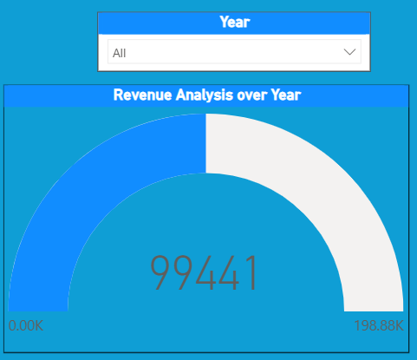

Explanation:
In this report we can analyse what is the total revenue that has been generated over years. Can find out where we have draw back in the previous year so that we can increase the revenue in the present and future years.

Conclusion:
The Power BI dashboard effectively answers key business questions through interactive and insightful visualizations.
When combined with the PBIX file, this report forms a complete capstone submission suitable for academic and professional evaluation.

